Summary

This document guides you to setup a simple platform to view Grafana and Prometheus capability with Istio mesh services.

*Note: This do not cover the installation of Kubernetes cluster.*

Install Istio

1. Enable Istioctl

cd istio-1.15.2

export PATH=$PWD/bin:$PATH

1. Install Istio with default profile

istioctl install

1. Enable Istio side car injection to default namespace

kubectl label namespace default istio-injection=enabled

1. Deploy Grafana and Prometheus

kubectl apply -f samples/addons/grafana.yaml

kubectl apply -f samples/addons/prometheus.yaml

Deploy book info application

1. Deploy book info application, routing and gateway

kubectl apply -f istio-1.15.2/samples/bookinfo/platform/kube/bookinfo.yaml

kubectl apply -f istio-1.15.2/samples/bookinfo/networking/destination-rule-all.yaml

kubectl apply -f istio-1.15.2/samples/bookinfo/networking/bookinfo-gateway.yaml

1. Export ingress IP and port for testing purpose

export INGRESS_HOST=$(kubectl get po -l istio=ingressgateway -n istio-system -o jsonpath='{.items[0].status.hostIP}')

export INGRESS_PORT=$(kubectl -n istio-system get service istio-ingressgateway -o jsonpath='{.spec.ports[?(@.name=="http2")].nodePort}')

export GATEWAY_URL=$INGRESS_HOST:$INGRESS_PORT

1. Test the application availability.

curl -s "http://${GATEWAY_URL}/productpage" | grep -o "<title>.*</title>"

Expected output:



Grafana and Prometheus

1. Launch Grafana by opening terminal and executing the command below

cd istio-1.15.2

export PATH=$PWD/bin:$PATH

istioctl dashboard grafana

1. Using the same PC from step 1, open a browser and key in <http://localhost:3000> in the address bar.
2. Generate at least 100 data for Grafana. Use the same terminal from deploy book info application section, and execute the following command

for i in {1..100}; do curl -s "http://${GATEWAY_URL}/productpage" | grep -o "<title>.*</title>"; done

1. Use explore mode to view available metrics and to try out promQL query.

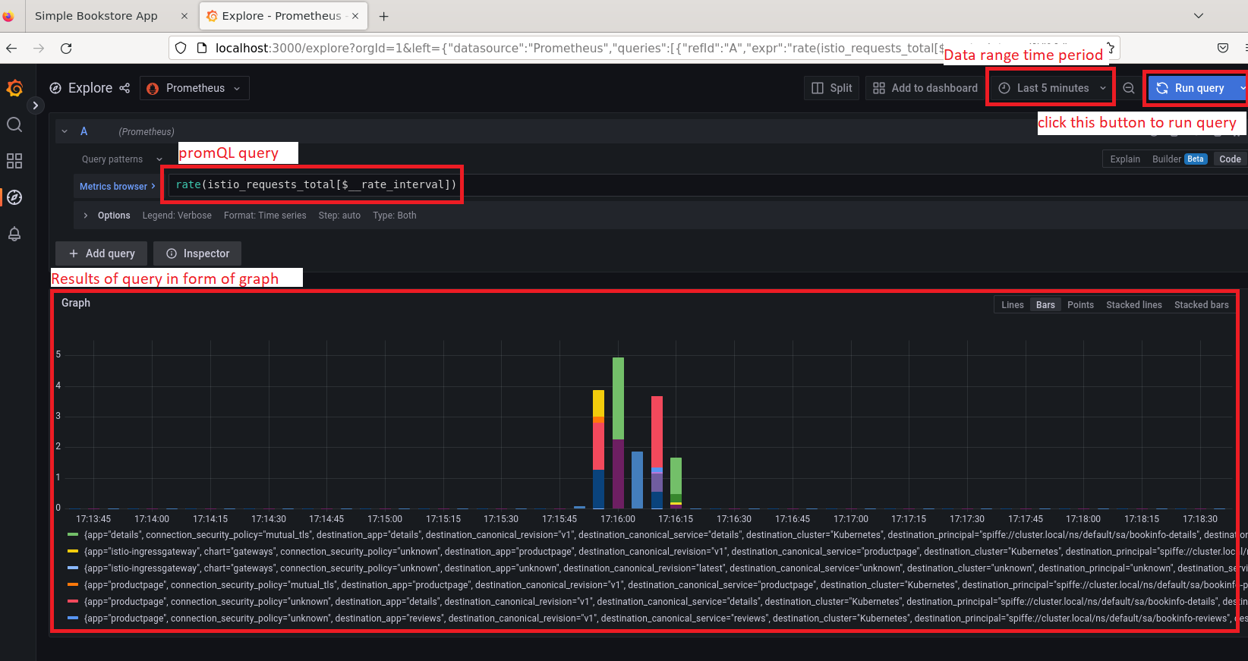

* 1. promQL refers to Prometheus query language, you can also put just the metrics only to see the data without any aggregation.
  2. Result data visualization is limited on explore mode compared to panels, but its good enough for quick checking.
  3. Data range period specify the time stamp range in which Grafana will extract the metrics value from for the current query.
  4. Run query button can be press manually to execute query or set to recurring.

1. Create a custom panel on new dashboard to show data collected from metrics.

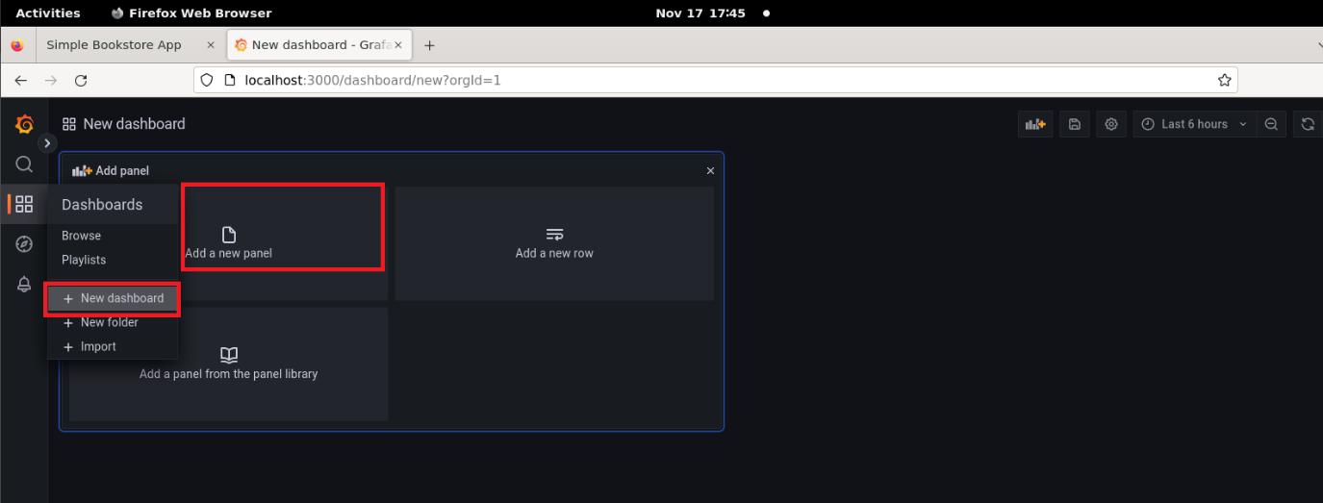

* 1. Create a new dashboard by clicking on new dashboard, and then click new panel to create a new panel.

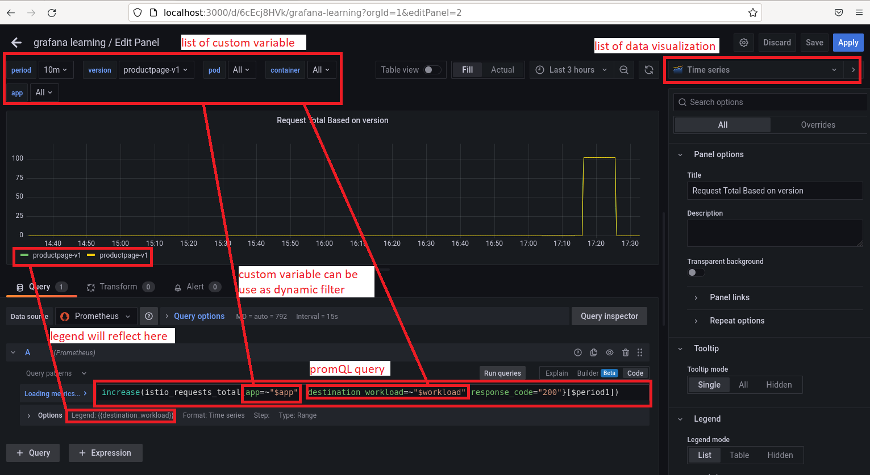

* 1. promQL query in a panel can be integrated with custom variable as afilter and the legend of the graph also can be customized to show data based on the filters.

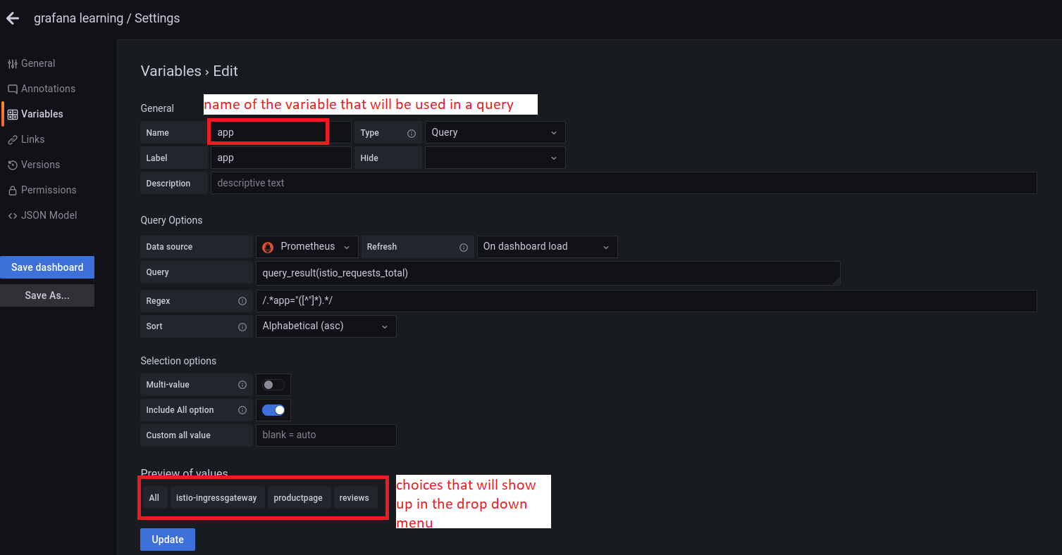

* 1. Example of variable is this app variable, which allows user to filter the data based on application.

1. Import the sample dashboard (grafana_learning.json) included in the repo.

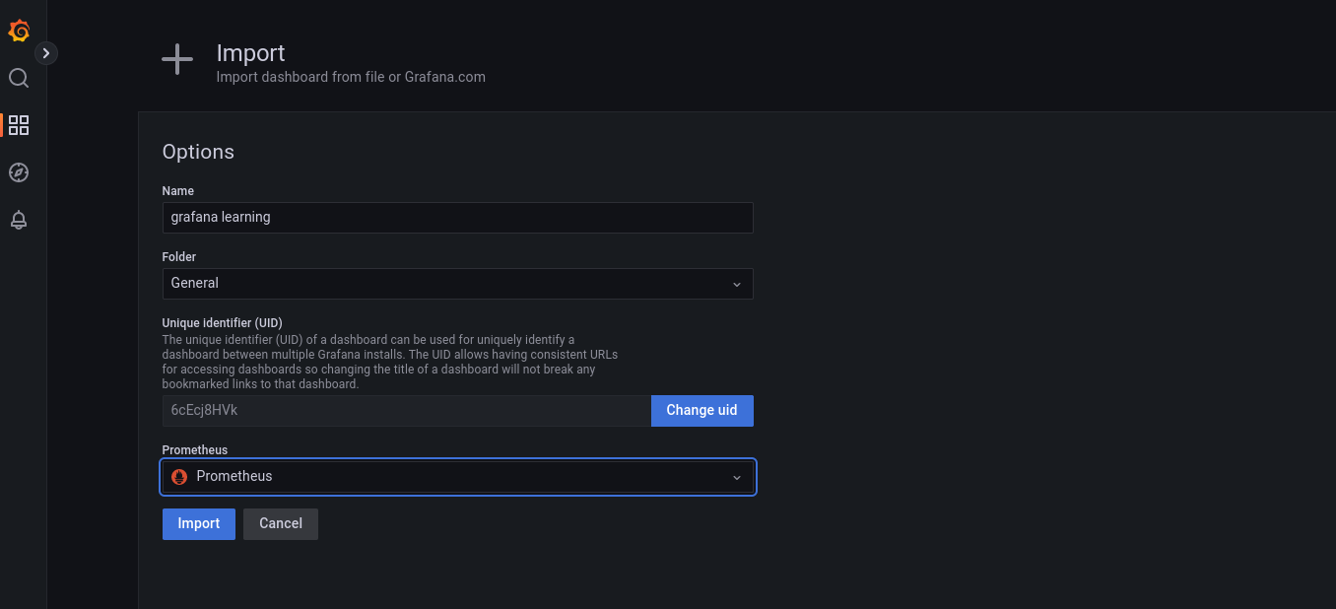

1. Once done, you can clean up the book info application by executing the following command.

istio-1.15.2/samples/bookinfo/platform/kube/cleanup.sh

1. You can remove Istio from your cluster using these command

istioctl uninstall --purge

kubectl delete namespace istio-system